Geography Initial Assignment
Look at the information below and answer the questions at the end. You may either handwrite or type your answers. Hard copies should be handed to your teacher at the end of your first lesson OR electronic copies may be emailed to your teacher, not later than 6pm on the day of your first lesson.
You will need to research some of the terms and processes.

Source A – Map Showing Recent Earthquakes and Volcanic Activity
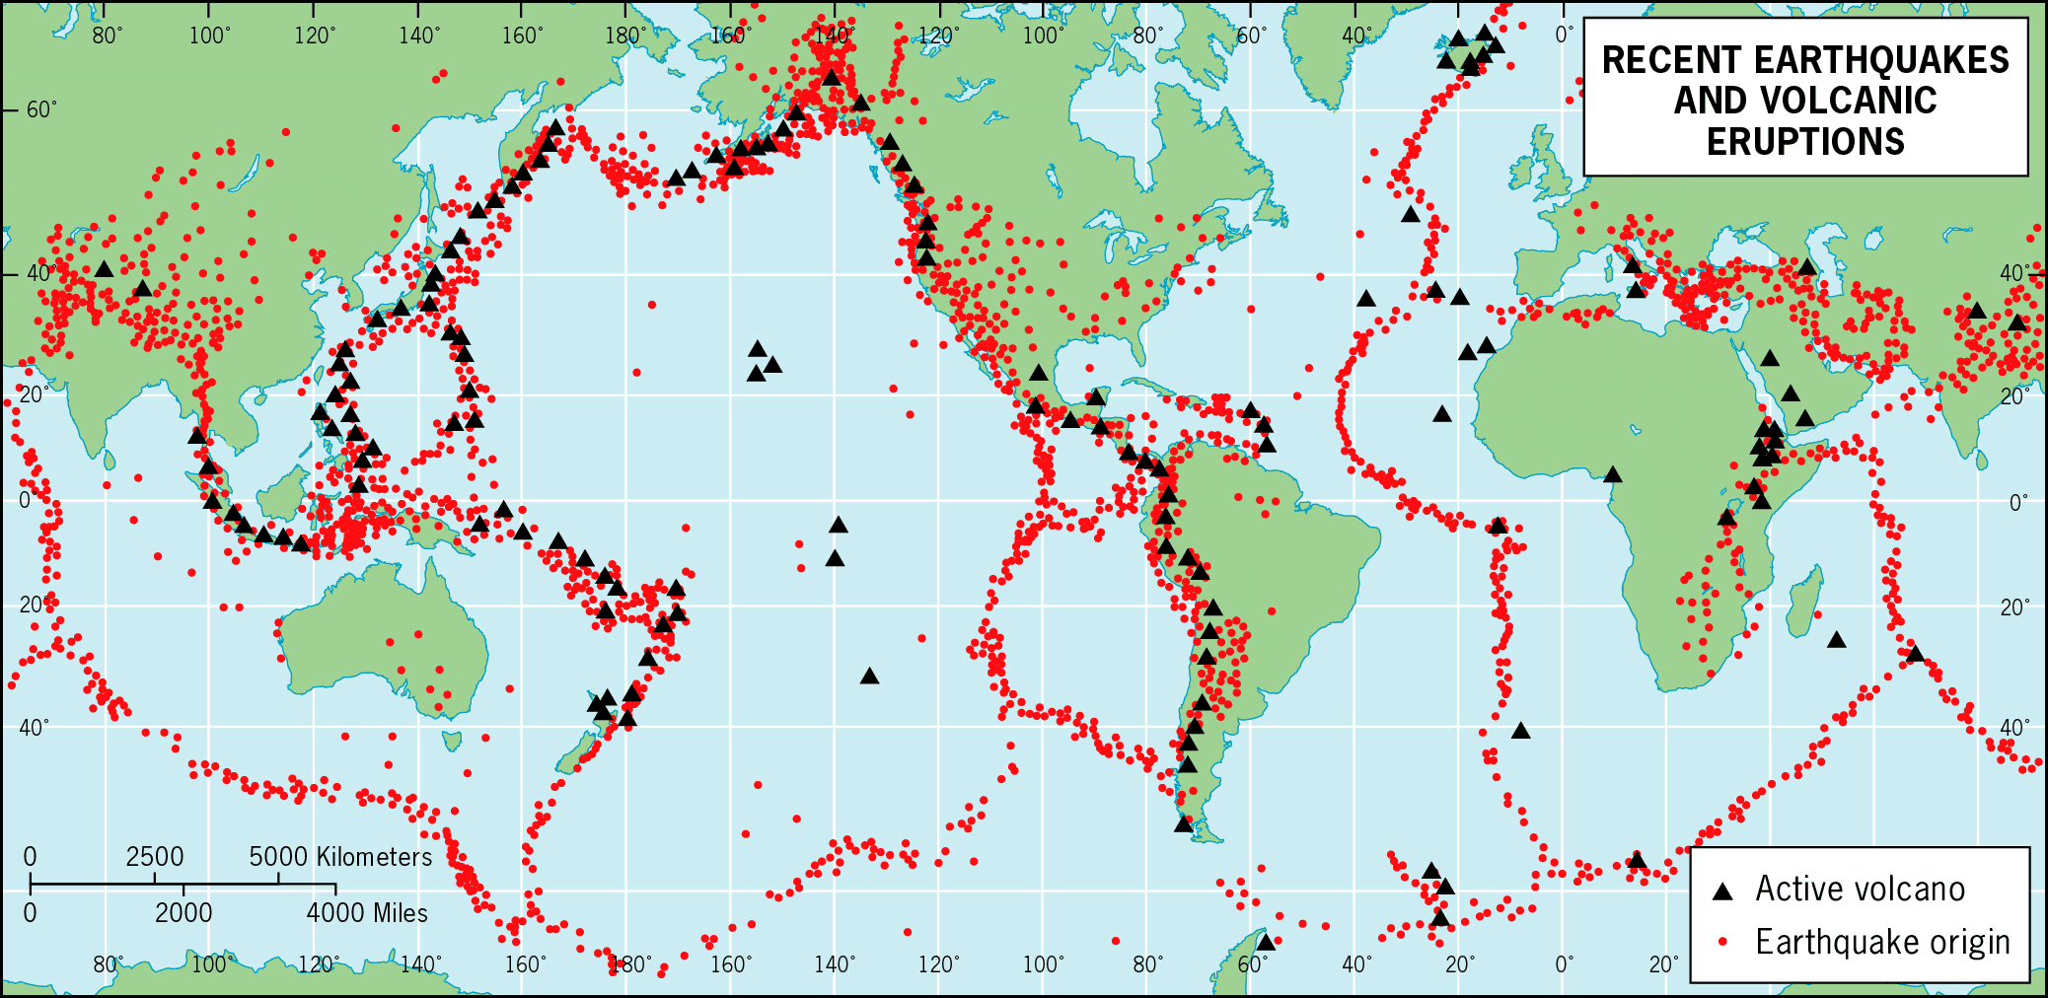
Source B – The Earth’s Tectonic Plates
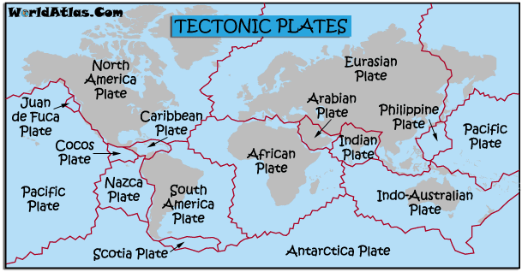

Source C – Extract from textbook on Tectonics
Tectonic hazards are hazard events caused by tectonic plates colliding into each other, moving against each other, moving apart or moving towards each other leading to subduction between a less dense plate and a more dense plate.
Examples of tectonic hazards include:
- Volcanoes - these occur when hot magma is forced to the Earth's surface through fissures and cracks in the Earth's crust.
- Earthquakes - these most commonly occur when two tectonic plates move against each other. Rocks break underground at the centre of the earthquake, and then the Earth's crust shakes when energy is released.
- Tsunamis – potentially devastating waves caused by the rapid displacement of water following a major earthquake.

Source D – Lahar damage Indonesia 2015
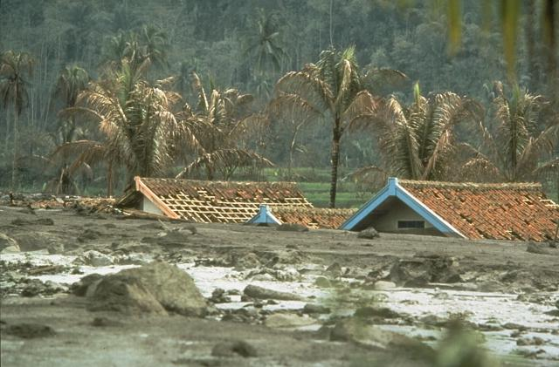

Questions
1 – Earthquakes are an example of a hazard associated with living in a region that experiences tectonic activity. What other hazards can you identify and describe? (At least 5 needed)
2 – What is the spatial relationship between plate margins and tectonic hazards?
3 – Why would anyone live in an area that is plagued by tectonic hazards?
4 – Tectonic activity such as an earthquake can trigger secondary hazards such as landslides. What other secondary hazards can you identify and how do they occur?
5 – Why do some volcanoes occur far away from the vast majority, such as Manua Loa in Hawaii?
Please answer in paragraph form and describe processes in full.
At A level knowledge of case studies is crucial, include these wherever possible.

