Summer project
RE-DESIGN / RE-INVENT
Watch / Pocket watch / Pop Swatch / G-shock / Jewellery Design / Armour project (3D)
As part of your preparation for the 3D Design course you are required to complete an independent task which will give your teacher an insight into your research, organisation and creative skills....
You must gather information about your favourite artist or designer and begin to form ideas & opinions about what you see. So basically you need to write a page of A4 on why you picked your artist and how it helped you design your work.
Think about types of design and purposes Eg, Gaming, Extreme sports, Steampunk, Technoir, gothic, mass effect, fashion. Try to find a subject that really interests you and go well beyond the classic ideas for jewellery.
A few examples:
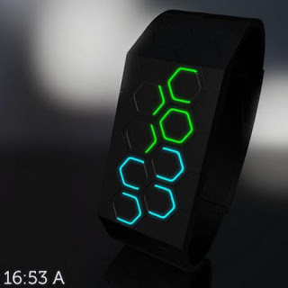

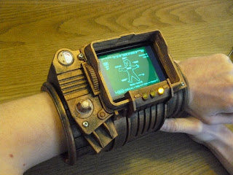

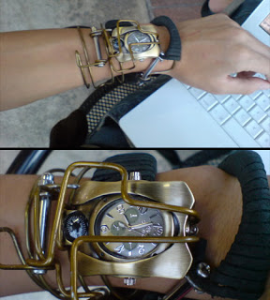

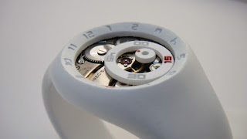
Collect a minimum of 4 images of their work and print the images onto an A4 sheet in colour.
This is very important!!! You must hand write approximately 500 words (1 side of A4 paper) about what you think of the artist/designers work and make specific reference to at least one of the chosen images... Describe some of the materials the
Finally using your artistic & creative talents to redesign a watch in the style of your chosen artist/designer, you can use the artist use’s, discuss how their use of colour may affect the design, what type of people would be attracted to this work?.
You can collect watch templates off google image search by typing in watch template. Alternatively I have saved some on the shared drive for the blog (link below) But in all honesty you are better off drawing/sketching in pen, pencil or digital paint your own design or modelling it out on Sketchup, Zbrush or Proengineer if you have access to these software packages
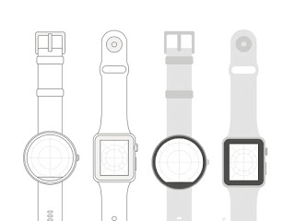
Alternatively you can use you own drawing / CAD or construction talents to create your design from scratch.
In total you will need to submit a minimum of 3 sheets...
1. Artist/designer images
2. Review of the artist/designers work
3. A watch / armour/ jewellery design in the style of the chosen artist
Please complete this task and bring it to your first lesson when you start college. Remember its meant to be fun and creative.
Good luck:)

