Appointment Bookings
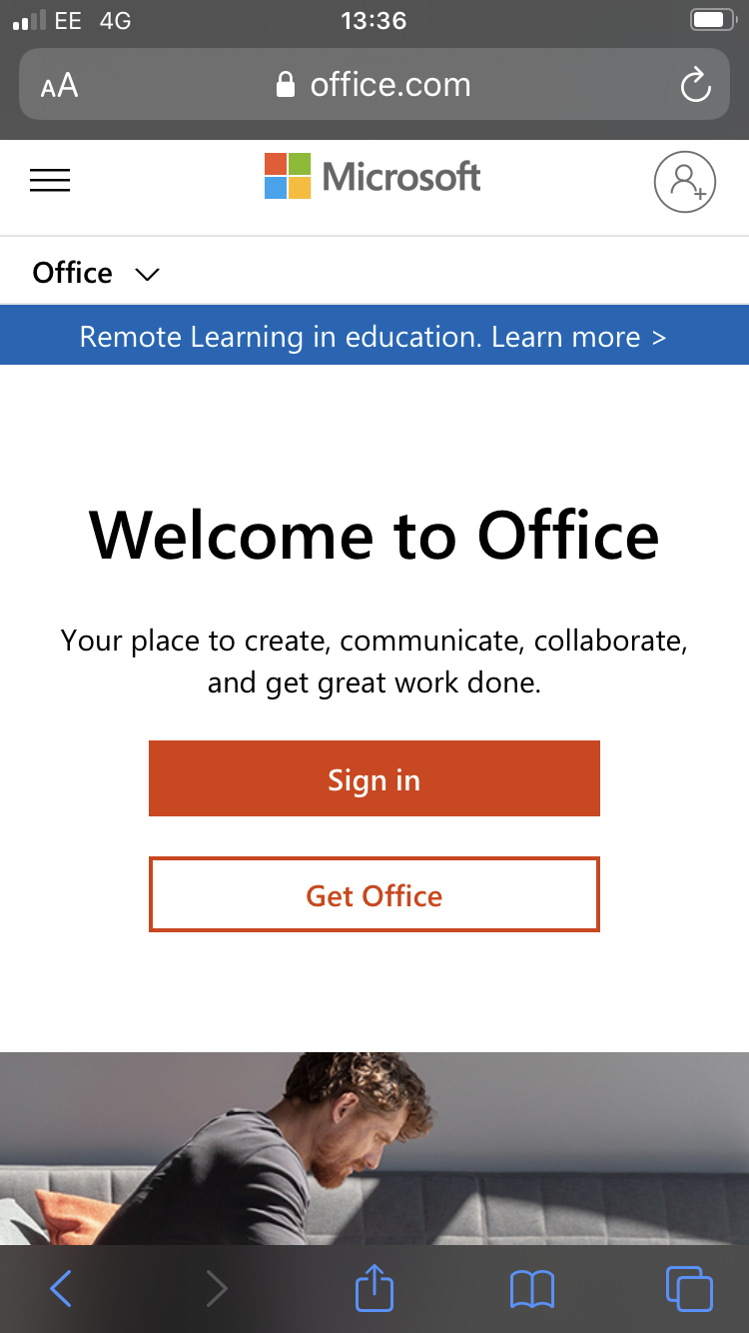
To access the exam/careers appointment booking system it is important that you are logged into your college Office 365 account on the internet browser on your device.
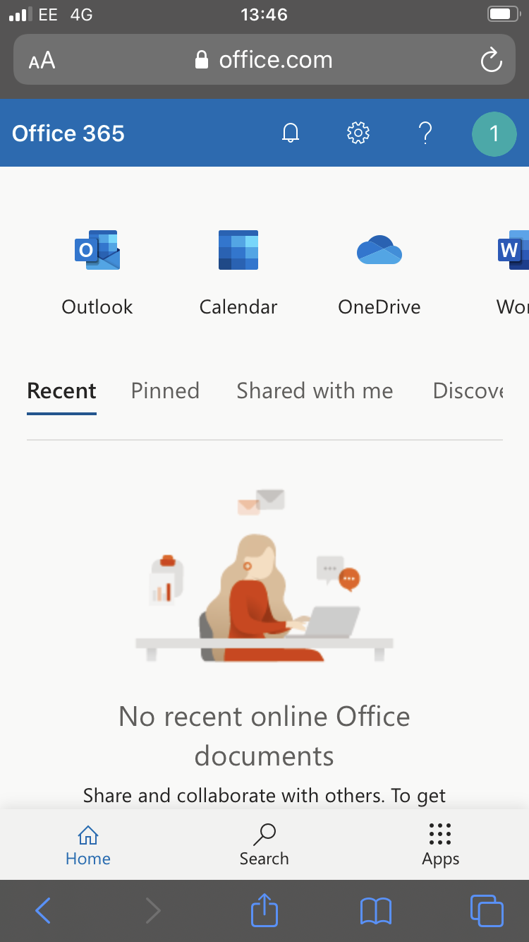
To do this go to https://www.office.com/ on the device you wish to use and sign in using your college email address and password.

This will take you through to your suite of Office 365 applications.

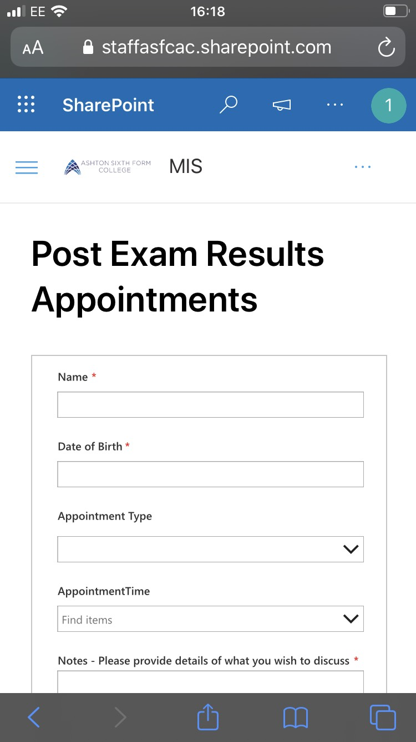
Once you have signed in you can then access the booking system by clicking on the link provided or copying and pasting the link into your internet browser.

https://staffasfcac.sharepoint.com/sites/studentsite/MIS/SitePages/Post-Exam-Results-Appointments.aspx

You may need to reload the page if it does not appear at the first attempt.

