ENTRY REQUIREMENTS
(Admission in Sept 2019)

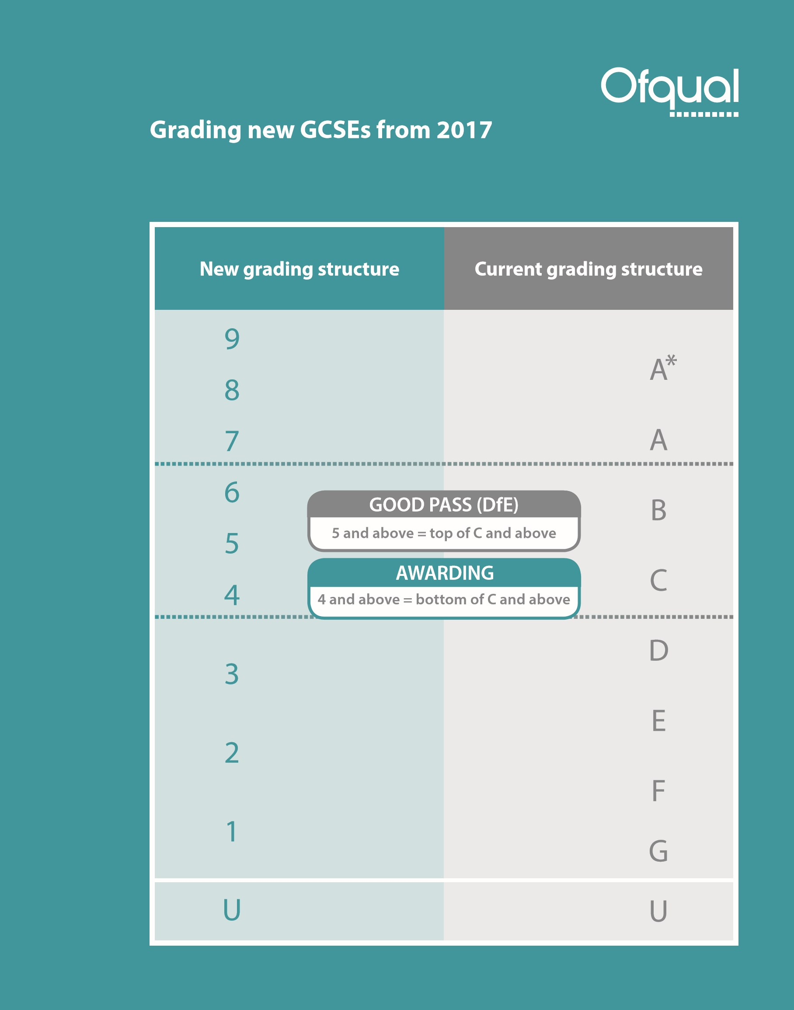

A Levels and Vocational courses available for September 2019

A Levels/Mixed Study (Students choose 3 from the list below. If the student is predicted high grades they may study 4 from the list below) | Full time Vocational (Students study one course from the list below at Level 3 or Level 2)
Accounting (A-Level)  Applied Science  Art & Design – 3D Design & Technology (A-Level)  Art & Design – Fine Art, Craft & Design (A-Level)  Art & Design – Graphic Design (A-Level)  Art & Design – Photography (A-Level)  Biology (A-Level)  Business (A-Level)  Business (Vocational - A-Level equivalent)  Chemistry (A-Level)  Computer Science (A-Level)  Criminology (Vocational - A-Level equivalent)  Dance (A-Level)  Drama & Theatre (A-Level)  Economics (A-Level)  English Language (A-Level)  English Literature (A-Level)  English Language & Literature (A-Level)  Film Studies (A-Level)  Further Mathematics (A-Level)  Geography (A-Level)  Health & Social Care (Vocational - A-Level equivalent) * NEW  History (A-Level)  Information Technology (Vocational - A-Level equivalent)  Law (A-Level)  Law (Vocational - A-Level equivalent)  Mathematics (A-Level)  Media Studies (A-Level)  Music Performance (Vocational - A-Level equivalent) * NEW  Music Technology – Music Production & DJ (Vocational - A-Level equivalent) * NEW  Music Technology – Studio & Live Engineering (Vocational - A-Level equivalent) * NEW  Philosophy, Ethics & Religion (A-Level)  Physics (A-Level)  Physical Education – Fitness & Coaching (Vocational - A-Level equivalent)  Physical Education – Sport & Exercise Science (Vocational - A-Level equivalent)  Politics (A-Level)  Psychology (A-Level)  Public Services (Vocational - A-Level equivalent) * NEW  Sociology (A-Level)  Spanish (A-Level)  Video Games Development (Vocational - A-Level equivalent) | Level 3 (2 year pathway)  Business  Early Years Educator (Childcare & Education)  Forensic Science  Health & Social Care  Information Technology  Media Production (TV & Film)  Music Production  Public Services  Sport  City in the Community – Sport & Football Programme* NEW
Level 2 – (3 year pathway – Level 2 then progression to Level 3)
Business
Early Years Education & Care (CACHE)
Media Production (TV & Film)
Public Services

Admissions Requirements for September 2019

XL PROGRAMME

- 7 GCSEs at grade 7 including English Language or Maths (with no lower than a 5 in the other)

A LEVEL STUDY PROGRAMME

- 2 GCSEs at grade 6, 2 x GCSEs at grade 5, 2 GCSEs at grade 4 including English Language and Maths
- Individual course requirements must also be met

MIXED STUDY PROGRAMME

- 2 GCSEs at grade 5 and 3 GCSEs at grade 4 or above including English Language and Maths
- Individual course requirements must also be met

FULL TIME VOCATIONAL STUDY PROGRAMME

Level 3 (2 year pathway)

- 4 GCSEs* at a grade 4 or above. A minimum of a grade 3 in English Language and a grade 2 in Maths must be achieved
- Individual course requirements must also be met

A student who has not achieved a minimum of a Grade 4 in English Language and/or Maths will be enrolled on to an appropriate English/Maths course alongside their Level 3 study programme

Level 2 (3 year pathway)

- 3 GCSEs* at a grade 3 or above. A minimum of a grade 2 in English Language and Maths must be achieved
- Individual course requirements must also be met

A student who has not achieved a minimum of a Grade 4 in English Language and/or Maths will be enrolled on to an appropriate English/Maths course alongside their Level 2 study programme

Full time Vocational pathway
*A Level 2 Certificate at Merit/Distinction can replace 1 GCSE
*A Level 2 Extended Certificate at Merit/Distinction would replace 2 GCSEs
*A Merit/Distinction achieved in a Level 2 Diploma in the same or a related subject with Grade 3 in English
Language and no lower than a Grade 2 in Maths will be considered

A-LEVELS/MIXED STUDY– SPECIFIC ENTRY CRITERIA
Below you will find A-Level/Mixed study courses which require additional entry criteria. Please note entry requirements can be subject to change at any time.
Subject | Course type | Exam board | Assessment | Specific Entry Criteria
Accounting | A-Level | AQA | 100% exam | GCSE grade 6 in GCSE Maths
Applied Science | Vocational A Level  (Subsidiary Diploma) | Edexcel | 100%  coursework | GCSE grade 4 in GCSE Maths plus a  minimum of 2 x 4 in GCSE Science or Applied Science  This course cannot be studied alongside A-Level Biology
Art and Design  - 3D Design  - Fine Art  - Graphic Design  - Photography | A-Level | EDUQAS | 100% coursework and practical  exam | GCSE Art & Design is preferred but not essential
Biology | A-Level | AQA | 100% exam | 3 GCSEs at Grade 6 which must include Biology and Chemistry or Combined Science. GCSE grade 5 in Maths  It is strongly advised students take another  Science, PE, Psychology or Geography alongside Biology
Business | A-Level | Edexcel | 100% exam | GCSE grade 5 in Maths
Business | Vocational A Level  (Subsidiary Diploma) | Edexcel | 100% coursework | No additional requirements
Chemistry | A-Level | OCR | 100% exam | 3 GCSEs at grade 6 which must include Chemistry and Biology or Combined Science. GCSE grade 5 in Maths.  Students must take another Science OR Maths at A-Level (can include Computer Science)
Computer Science | A-Level | OCR | 80% exam  20% non-  examined  assessment | 3 GCSEs at grade 6 which must include GCSE Maths
Criminology | Vocational A Level  (Certificate) | WJEC | 50% exam  50%  controlled  assessment | No additional requirements
Dance | A-Level | AQA | 100% exam  50% theory  50% practical | No additional requirements
Drama & Theatre | A-Level | Edexcel | 40% exam  30% coursework  30% practical | No additional requirements
Economics | A-Level | Edexcel | 100% exam | GCSE grade 6 in Maths
English Language | A-Level | EDUQAS | 80% exam  20% non-  examined  assessment | No additional requirements
English Literature | A-Level | Edexcel | 100% exam | GCSE grade 5 in GCSE English Language and GCSE English Literature
English Language and Literature | A-Level | Edexcel | 80% exam  20% non-examined  assessment | GCSE grade 5 in GCSE English Language and GCSE English Literature
Film Studies | A-Level | EDUQAS | 70% exam  30% non-examined assessment | No additional requirements
Further Maths | A-Level | Edexcel | 100% exam | GCSE grade 7 in Maths  At least 3 x 6 grades & 2 x 5 grades in other GCSE subjects one of which should be a Science
Geography | A-Level | Edexcel | 80% exam  20% coursework | Grade 5 in GCSE Geography plus a GCSE grade 4 in Maths
Health & Social Care | Vocational A Level  (Certificate) | CACHE | Coursework with an externally assessed unit | This course is equivalent to 1.5 A-Levels and is studied alongside 2 other subjects
History | A-Level | Edexcel | 80% exam  20% non- examined assessment | Grade 5 in GCSE History or a  relevant essay based subject
IT | Vocational A Level  (Subsidiary Diploma) | Edexcel | 100% coursework | GCSE grade 4 in Maths
Law | A-Level | AQA | 100% exam | No additional requirements
Law | Vocational A Level  (Subsidiary Diploma) | Edexcel | 100% coursework | No additional requirements
Maths | A-Level | Edexcel | 100% exam | GCSE grade 6 in Maths  At least 3 x 6 grades & 2 x 5 grades in other GCSE subjects one of which should be a Science
Media Studies | Vocational A Level  (Subsidiary Diploma) | EDUQAS | 70% exam, 30% coursework | No additional requirements
Music Performance | Vocational A level (Subsidiary Diploma) | Pearson | Mix of internal and external assessment | Audition required
Music Technology  - Music Production & DJ  - Studio & Live Engineering | Vocational A Level  (Subsidiary Diploma) | Edexcel | Mix of internal and external assessment | No additional requirements
Physics | A-Level | OCR | 100% exam | 3 GCSEs at grade 6 which must include Physics or Combined Science and Maths  It is strongly advised that students take Maths at A-Level alongside this course
Politics | A-Level | Edexcel | 100% exam | Grade 5 in GCSE History or a relevant essay based subject
Philosophy, Ethics & Religion | A-Level | EDUQAS | 100% exam | No additional requirements
Psychology | A-Level | AQA | 100% exam | GCSE grade 5 in Maths
PE  - Sport & Exercise Science  - Fitness & Coaching | Vocational A Level  (Subsidiary Diploma) | Edexcel | 100% coursework | Sport and Exercise strand should have minimum of a grade 4 in GCSE Biology or 2 x 5 grades in core and additional Science  Fitness and Coaching preferably the above
Public Services | Vocational A Level  (Subsidiary Diploma) | Edexcel | 100% internal assessment | No additional requirements
Sociology | A-Level | AQA | 100% exam | GCSE grade 5 in English Language or  English Literature
Spanish | A-Level | EDUQAS | 100% exam | Grade 6 in GCSE Spanish or native speaker
Video Games  Development | Subsidiary Diploma | Edexcel | 100% coursework | Grade 4 in Maths is desirable

FULL TIME VOCATIONAL LEVEL 3 – SPECIFIC ENTRY CRITERIA
Below you will find Full time Vocational courses which require additional entry criteria. Please note entry requirements can be subject to change at any time.
Course | Course type | Exam board | Assessment | Specific entry Criteria
Business | Extended Diploma | Edexcel | A mix of assessment – internal and  external | Grade 4 in Maths
City in the Community – Football Coaching with Manchester City | Extended Diploma | Edexcel | A mix of assessment – internal and  external | Grade 4 in English Language and Maths  You will be invited to attend a taster session to assess your ability to play football at a competitive level
Early Years Education (Childcare & Education) | CACHE Diploma | CACHE | A mix of assessment – internal and  external | Grade 4 in English Language or Maths
Forensic Science | Extended Diploma | Edexcel | A mix of assessment – internal and  external | 2 x 4 grades in GCSE Science or Applied Science
Health & Social Care | Extended Diploma | BTEC | A mix of assessment – internal and  external | No additional requirements
Information Technology | Extended Diploma | Pearson | 100% internal assessment | Grade 4 in Maths
Media Production (TV & Film) | Extended Diploma | Pearson | 100% internal assessment | No additional requirements
Music Production | Extended Diploma | Edexcel | A mix of assessment – internal and  external | Grade 3 in Maths preferred
Public Services | Extended Diploma | Edexcel | A mix of assessment – internal and  external | No additional requirements
Sport Extended Diploma | Extended Diploma | Edexcel | A mix of assessment – internal and  external | No additional requirements
FULL TIME VOCATIONAL LEVEL 2 – SPECIFIC ENTRY CRITERIA
Course | Exam board | Assessment | Specific entry Criteria
Business Diploma | OCR | 100% coursework | GCSE grade 3 in Maths
Early Years Education & Care Certificate | CACHE | 100% coursework | No additional requirements
Media Production Extended Certificate | Edexcel | 20% exam  80% coursework | No additional requirements
Public Services Diploma | BTEC | 100% coursework | No additional requirements

