**Results Day Information from the Exams Department**

**When is results day?**

**Thursday 14th August – from 8.30am**

* All level 3 qualifications, including:
* A level
* EPQ
* BTEC (Unit results and overall grades)
* Core Maths
* Criminology (both year groups)
* CACHE Health & Social Care & Childcare
* T Level Health
* T Level Education

**Thursday 21st August – from 8.30am**

All level 2 qualifications, including:

GCSE

**How do I access my results?**

Your overall qualification results(s) will appear on your CEDAR profile at 8:30am under the Results tab as follows:

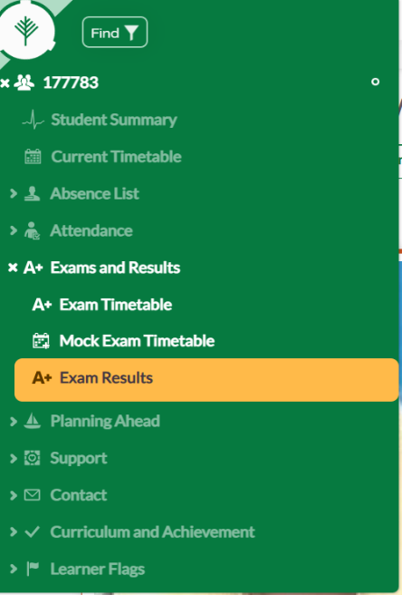A more detailed breakdown of your results will subsequently be sent electronically to your college e-mail account. Due to data protection, we cannot issue results to an alternative e-mail address or to anyone other than you. We strongly advise you to check that you can access to your email account before results day, just in case of any problems, including forgotten passwords.

**I cannot access my college e-mail account.  Who do I contact?**

From Monday 11th August onwards, you can contact college on 0161 330 2330 for IT facilitators to re-set your password.  You will need to answer security questions to re-set your account.  Once security is cleared, you will be issued with a new password. There will be a delay of approximately 1 hour while your re-set request processes. Please check your emails prior to results day to ensure you still have access.

**I can access my college e-mails, but I cannot find my results slip.**

Are you looking on the right day/time? Check the information above.

Then, check your ‘junk’ folder.

If the email containing your results is found in ‘junk’, you need to move this to your inbox to view your results slip attachment (you may need to close your e-mails down and start again if accessing via a mobile device).

If you have checked all the above and there is no email, wait until 9.00am and then contact [resultsqueries@asfc.ac.uk](mailto:resultsqueries@asfc.ac.uk) using your college email address and confirming:

* Full name;
* DOB;
* Subjects you are expecting results for

We will provide more advice as soon as we can.

**Results – next steps**

We hope you will be happy with your results, and all your hard work was worthwhile. But, if you have not received the grades you were expecting and have missed out on a university place or apprenticeship etc., we can help. Read the advice below for more information.

**Are teachers in college?**

A small number of staff are available in college to provide careers advice/clearing assistance and to discuss post result services but as it is the summer holidays, teaching staff are not expected in college.  They are also unlikely to be reading their emails.

**Exams staff availability**

The exams team will be happy to advise you about post results services (reviews of marking etc.)  Priority will be given to students who have lost a university place, an apprenticeship or a job offer due to their results. If you need to talk to us either come into college between 9am and 3pm, or use the dedicated email address: [resultsqueries@asfc.ac.uk](mailto:resultsqueries@asfc.ac.uk)

**Exam/Result Certificates**

Your certificates won’t arrive into college until late in the autumn term. You will be able to collect them from main reception in January. We will remind you via college’s social media accounts when certificates are available. Any certificates that aren’t collected within one year are destroyed and replacements will be need to be requested directly from exam boards for a fee.