**Year 1 Psychology**

**Initial assessment Task**

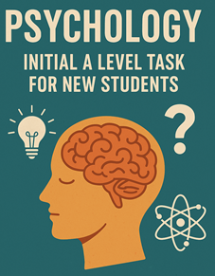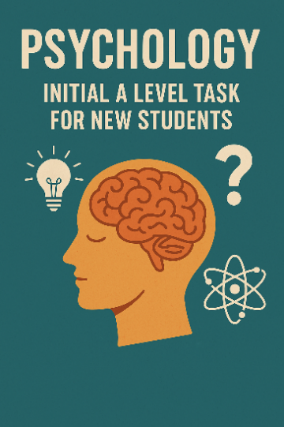

**Welcome to Psychology, where curiosity meets evidence and your mind becomes your laboratory.**

**In this introductory task, you'll start exploring how memory works, uncover why people behave the way they do, and challenge what you think you know about yourself and others. Psychology is not just about theories—it's about the real world and your experiences.**

**Whether you're intrigued by the mysteries of the brain, fascinated by human behaviour, or simply eager to understand yourself better, this task marks the beginning of a journey that’s as thought-provoking as it is empowering. Let’s dive into the science of what makes us… us.**

**Task Instructions:**

**The Title:** The Psychology of memory

**Task 1:** Watch the video on the Working Model of Memory.

<https://youtu.be/_JKo9h70TEw>

**Task 2:** Use the attached note taking template to make Cornell notes, create a revision mind map (use the template below or create your own) and a flashcard using the instructions below.

**Deadline:** This must be **brought in to your first Psychology lesson**

|  |  |
| --- | --- |
| Topic: | |
| Key Terms, ideas, dates, numbers etc: | Main notes: |

|  |
| --- |
| Summary: |

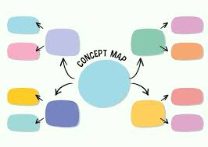

Please create a flash card in the following format;

On one side please write the key term or concept

On the opposite side please the relevant information or diagram.

Please example below

Memory is defined as the ability to encode, store, and retrieve information. It's a fundamental cognitive process that allows individuals to retain and recall past experiences

