**A1 Politics Induction Tasks 2025**

Welcome to A-Level Politics at Ashton Sixth Form College. In preparation for starting your course, please complete the tasks below and bring to your first lesson in September.

These tasks are in line with the A-Level Politics specification (below) and will help you to prepare for your initial assessment.

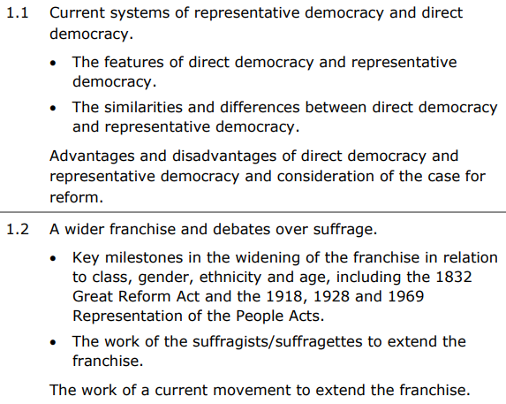

**Task one -** Define the following key terms:

|  |  |
| --- | --- |
| Legitimacy | Direct democracy |
| Representative democracy | Pluralist democracy |
| Democratic deficit | Participation crisis |
| Franchise / suffrage | Think tanks |
| Lobbyists | Constituency |

**Task two –** Find out the following about the UK’s democracy:

1. Identify three features of the UK’s representative democracy
2. Identify three types of direct democracy commonly used in the UK today
3. Identify two advantages and two disadvantages of representative democracy
4. Identify two advantages and two disadvantages of direct democracy

**Task three –** Find out the following information about participation in elections:

1. Who is your local MP?
2. What percentage of the votes did they get in the 2024 general election?
3. What percentage of eligible people voted in your constituency in the 2024 general election?
4. What percentage of eligible people turned out to vote nationally in the 2024 general election?
5. Who is the Mayor of Manchester?
6. What percentage of the vote did the current Mayor of Manchester win in the 2024 mayoral election?