***A-Level Physics Induction Activity***

Welcome to the Physics Department at Ashton Sixth Form College!

Your first things to do:

* Make sure you have a QR reader on your phone. Sometimes it can work straight through the camera app by scanning the QR codes below. If not download a QR reader for your phone.
* Watch the videos below and complete the tasks.

*In college you will have study periods every week in which you will be expected to complete independent study for all of you subjects. This will involve set tasks but also using your time productively to go over your class notes and reading forwards and pre-learning the next topics, so that you are familiar with them when you cover them in class – we call this flipped learning.*

*Below are some flipped learning tasks to get you started. These skills will all be covered in the first module you study when you start in September.*

**Make sure you bring your completed questions and revision resources to your first lesson in September**

Section A

Go on the YouTube Channel, Zphysics:

<https://www.youtube.com/channel/UC3L5MO3gJTlB09wmmHGW5Qg>

1. Rearranging equations Questions:

<https://youtu.be/EMOzbQxfdWw>

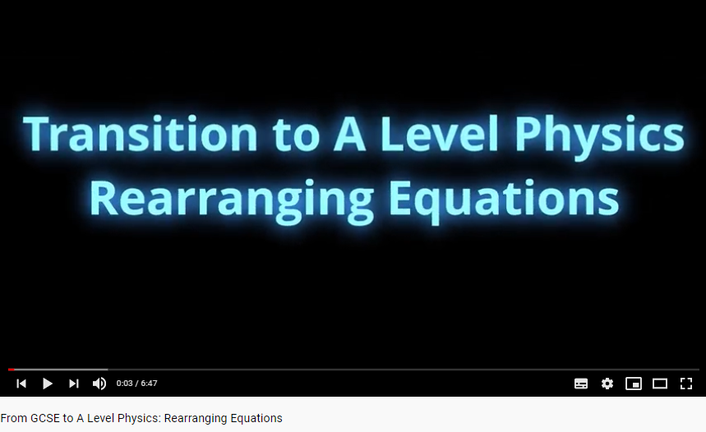

1. 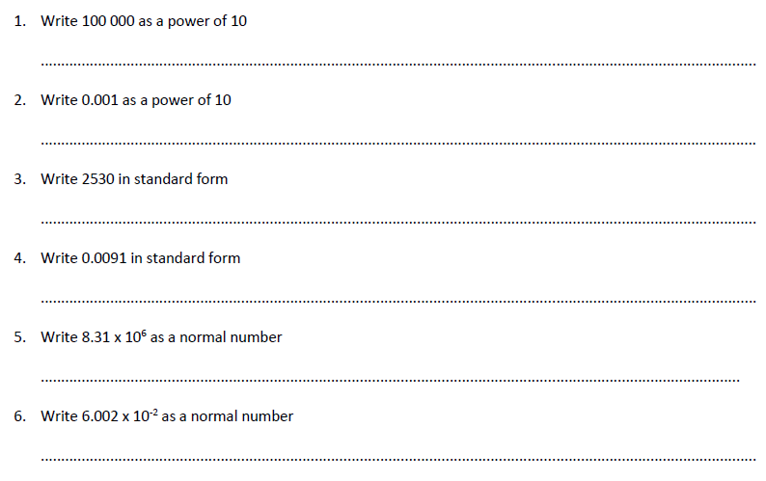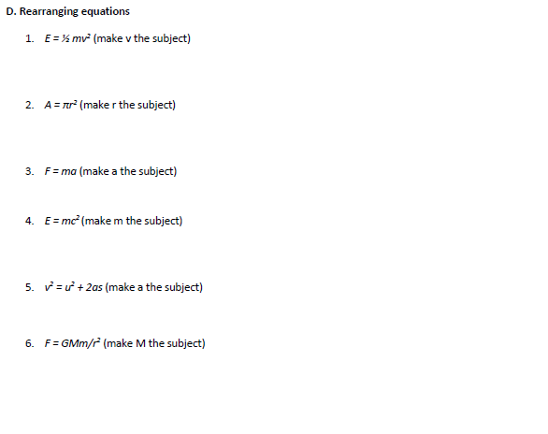Standard form Questions:

Section B

Watch this video on prefixes: https://youtu.be/213HxbVovng

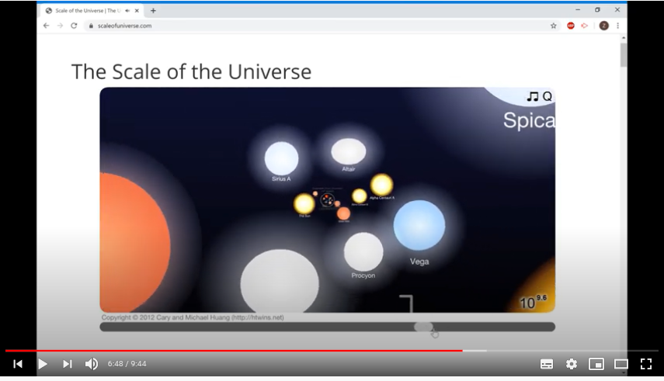

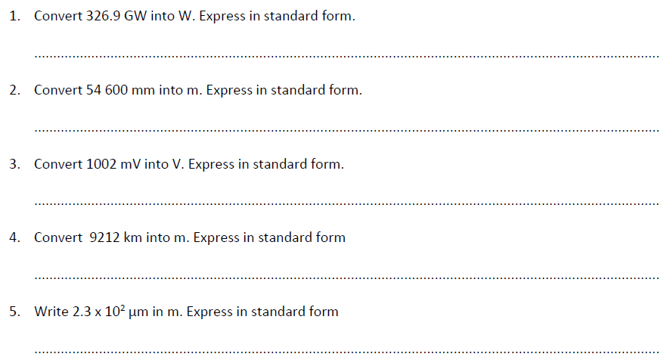Prefix Questions:

Section C

<https://youtu.be/VH4luBW05YQ> and <https://youtu.be/NnUeqjto33o>

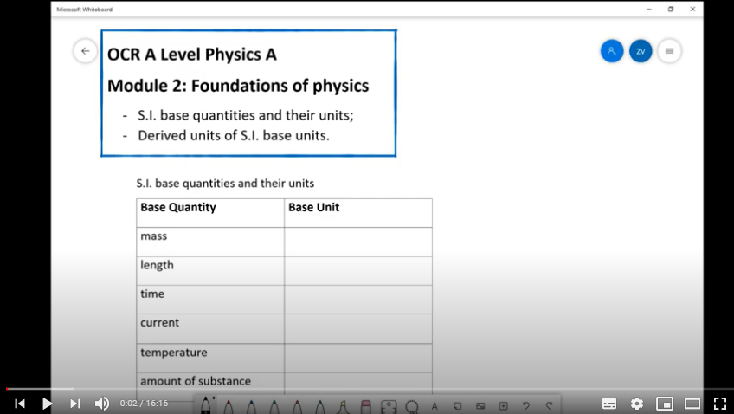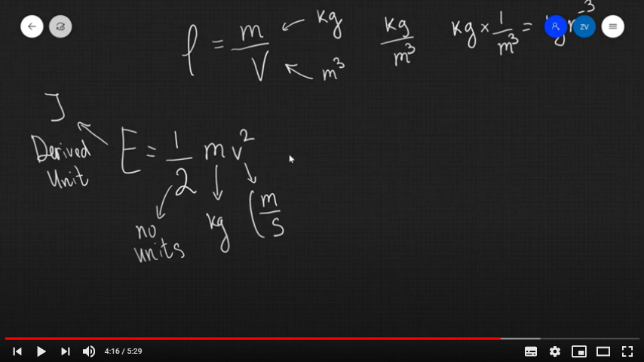

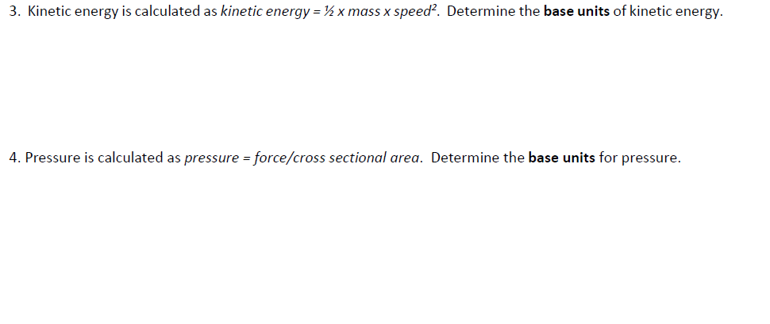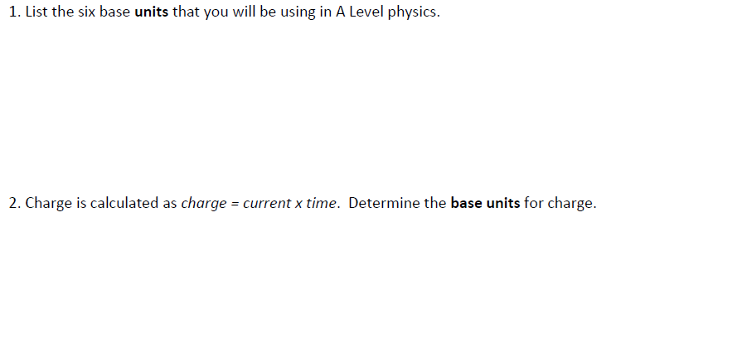Base Units Questions:

Section D

Produce some revision resources on the topics that you have flip learnt. These could be a mind map, flashcards, revision notes or something else of your choice.

Topics to cover:

* Rearranging equations
* Standard form
* Prefixes
* Base Units and deriving base units