Welcome to Medical Science (AAQ)

Congratulations on being accepted onto our Medical Science course!


To get you prepared for your first year please complete the following activities:
- Eukaryotic and Prokaryotic Cell Structure
- Common Biology Prefixes and Suffixes
- Structure of the Skeletal System
- What is Osteoporosis?
These will be collected in your first lesson and marked by your teacher.
Task 1 – Cell structure
Add labels to these diagrams and briefly describe the function of each organelle.
Animal Cells Plant Cells
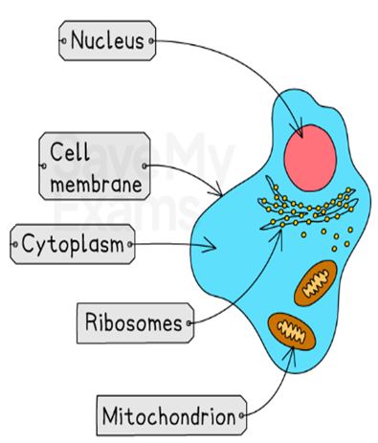
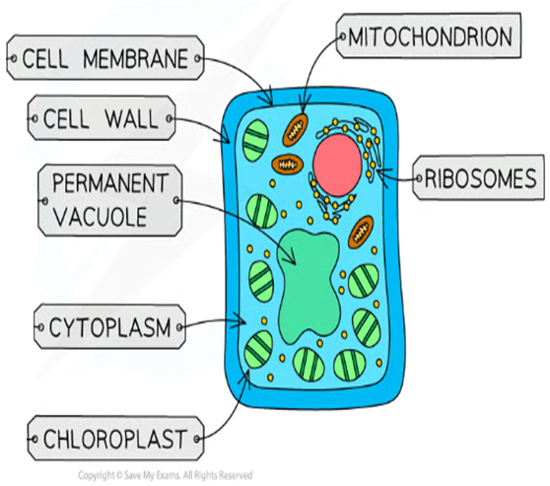

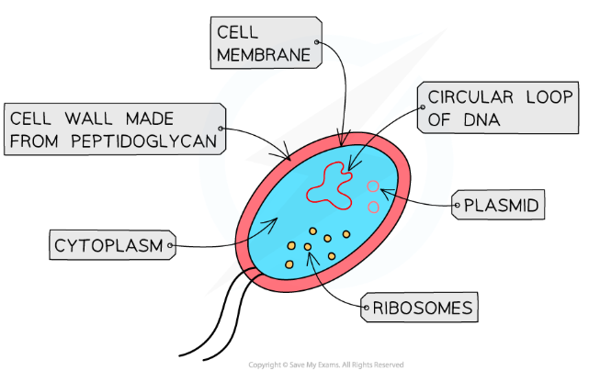
Prokaryotic Cells

Organelle Name | Brief Description of Function
Nucleus
Cytoplasm
Ribosome
Rough
Endoplasmic Reticulum
Cell Membrane
Cellulose Cell Wall
Circular Loop of DNA
Plasmid
Peptidoglycan Cell Wall
Chloroplast
Large Permanent Vacuole

Task 2 – Useful Biology terms
In Science, particularly biology, there are a lot of prefixes (the start of a word) and suffixes (the end of a word) which come up a lot! These tend to be Greek or Latin words but learning them helps understand what a new biology/ medical term means.
Osmo- |  | To break apart
End in -lysis |  | Cell
Word ends in -ase |  | Bone
Cyto- |  | To do with the lungs
Osteo- |  | Water
Myo- |  | Usually the name of an enzyme
Cardio- |  | Make
Pulmonary |  | To do with the heart
Endo- |  | Out of
Exo- |  | Self
Synth- |  | Light
Auto- |  | Into
Haemo- |  | Muscle
Ends in -itis |  | Nucleus
Karyo- |  | Blood
Photo- |  | Inflammation
Below are a few common ones, some you may be familiar with. Match up the prefix or suffix with its meaning.

Task 3 – Structure of the Skeletal System
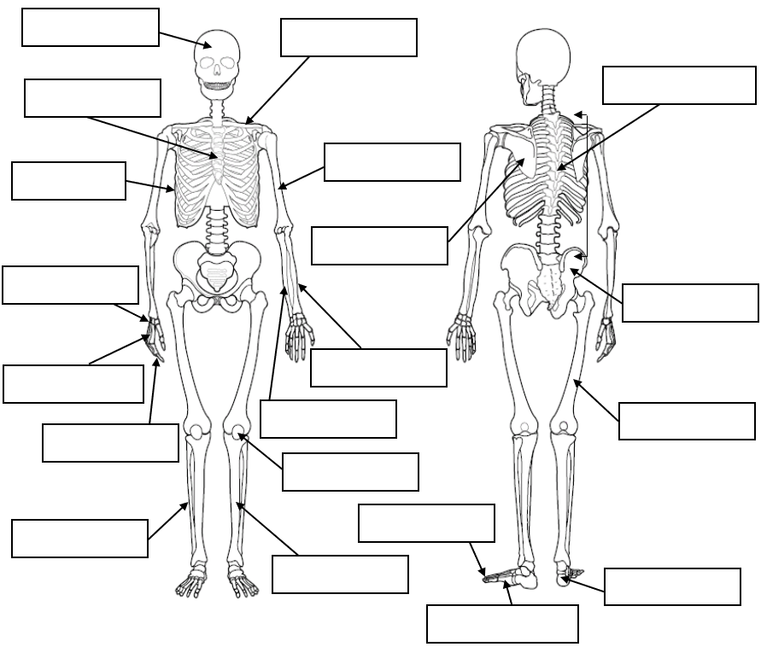
In medical science, you will learn about many different body systems. One of these is the Skeletal System. Please add the following labels to the diagram below.

Ulna | Tarsals | Radius
Pelvis | Cranium | Carpals
Femur | Humerus | Scapula
Tibia | Ribs | Vertebral Column
Fibula | Patella | Sternum
Metacarpals | Clavicle | Phalanges
Metatarsals | Phalanges | Vertebra
Task 4 – What is Osteoporosis?
As part of the Medical Science course, you will learn about a number of health conditions, how to diagnose them, what causes them, and how they are treated. One example is Osteoporosis. Research osteoporosis and explain what you have learned below. You should include the following information:
- What causes osteoporosis
- What are the symptoms?
- What is the prevalence of osteoporosis?
- What tests are carried out to diagnose osteoporosis
- What are some risk factors for developing osteoporosis?

