**A1 History Induction tasks**

In preparation in joining the History department in September, we would like you to complete the following activities, in line with the A level History specification (below):

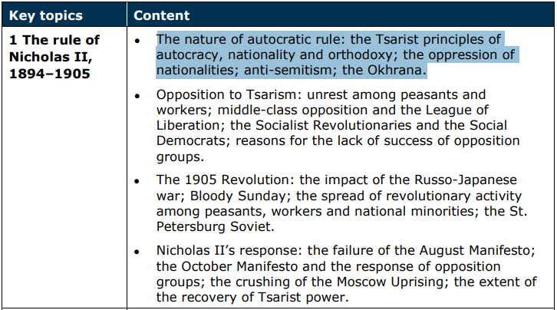

**Tasks:**

1. Use the internet to define the following terms, in the context of Tsarist Russia (1894-1917):

* Autocracy:
* Nationality:
* Orthodoxy:
* Anti-Semitism
* Okhrana:

1. Using the internet and the map overleaf plot where, within the Russian empire, you would find the following nationalities (circa 1900):

***Finns/Poles/Ukrainians/Belarussians/Georgians/Uzbeks/Afghans/Chinese/Estonians/***

***Armenians/Lithuanians/Yakuts/Jews***

1. Using the internet, identify any major natural landmarks/natural resources in the Russian empire & add to your map.
2. Using the internet & your research so far, identify where the Tsarist government was based & note what issues this may have caused in ruling the empire in the period up to 1917.

