The Brief:

An independent games producer is developing a new game which is set in the time of the Roman Empire. They want you to create models that are as historically accurate as possible.

They have commissioned you to undertake careful research into that era to create a set of models that will be used within the game, that are based on real Roman artefacts.

Task 1:
Your task is to find Roman artefacts that either inspire ideas or could be adapted to be used to create models for the Roman game. Models could be anything from weapons, vehicles, buildings or decorations.
Please find at least 3 artefacts, add a link to the original source and describe how this artefact influences your ideas.
Here’s a link to start you off
https://www.metmuseum.org/art/collection/search?searchField=All&sortBy=relevance

You can search for ‘Roman’ in the search bar.
See my example below and then complete the rest of the grid.

Screenshot of Artefact | Link to it online (URL) | How you would incorporate this into your model idea.
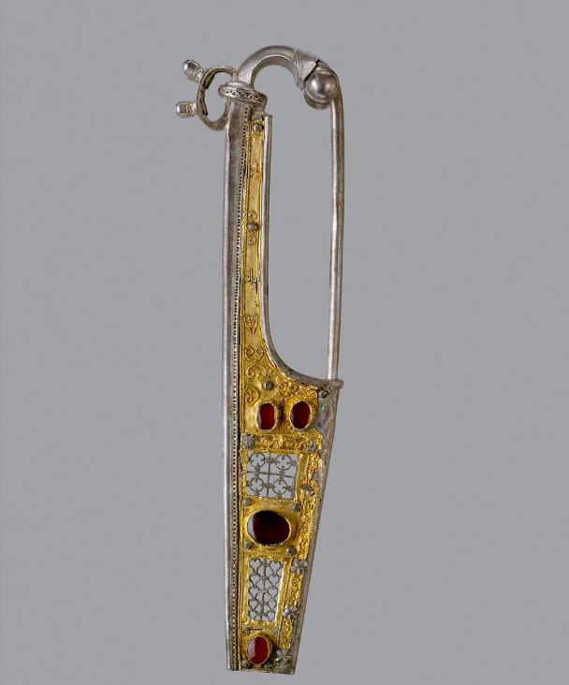 | https://www.metmuseum.org/art/collection/search/469961 | MY EXAMPLE: This is a piece of jewellery found in Europe around the year 100AD.  Although it’s designed to pin onto clothes the top looks like a handle with the pin being a hand guard. This could be turned into the handle of a sword for an emperor or someone similar with the handle encrusted with jewels.

Task 2:
Once this is done, look through current games and see how they do it. Consider your artefact research and then find similar models in current games to see how they have incorporated elements of their specific time period.
For example:
This is the hidden blade in Assassin’s Creed Valhalla
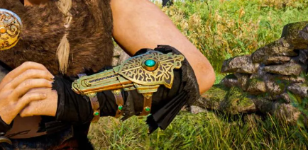
It could never exist in the time of the Vikings, as coiled springs hadn’t been invented. However, we accept it, because its design has been influenced by what we think of as Viking design.
When you google ‘Viking Jewellery’ you see that the patterns and markings are in-keeping with what we expect to see.
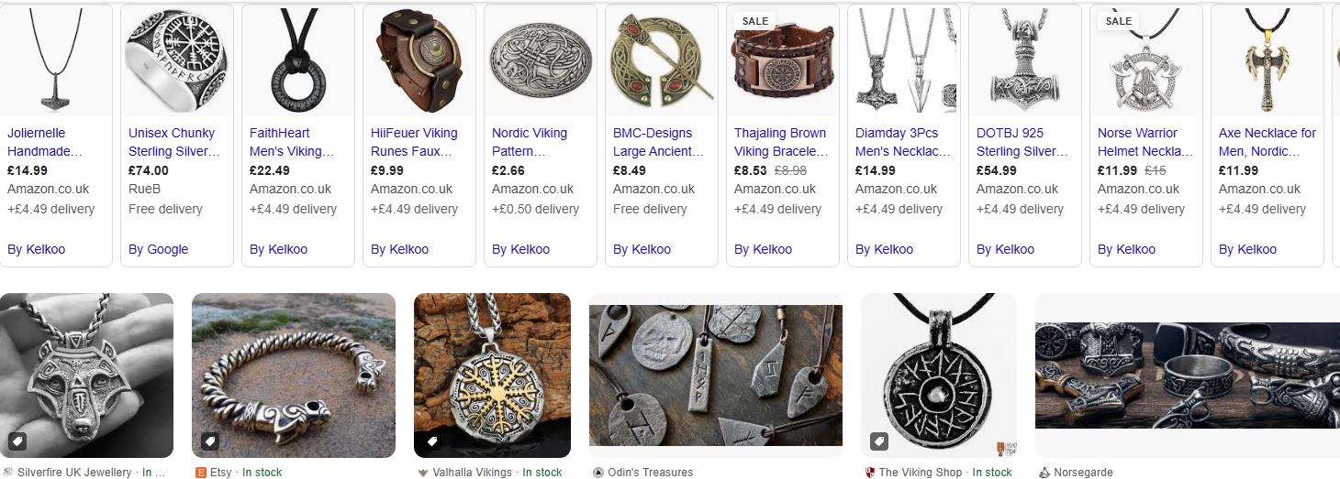

Complete the following grid with at least 3 models from current games.

Screenshot of model in game | Description of how the model fits the time period of the game.
 | MY EXAMPLE: This is the hidden blade in Assassin’s Creed Valhalla. You can see how they’ve designed the plate that sits on the forearm that has the lines and shapes of Viking jewellery. It is also made out of a metal that seems to fit with the time period. The blue/green jewel may not have been used in weapons but I might try to use a similar piece of jewellery when creating my idea of a sword.

