**Business BTEC Initial Assignment – Unit 3 Finance Exam – Learning Aim A – Personal Finance**

It is important that students understand the various ways that you can pay for things, the advantages and disadvantages of each and the best scenario to be using these. Pick 8 different ways to pay from the specification list below and create a mind-map to show your understanding. This could be physically produced on paper or also created electronically. Have this available to present to your teacher at college.

**A2 Different ways to pay (Pages 48-49)**

The use of money as a payment method, advantages and disadvantages of:

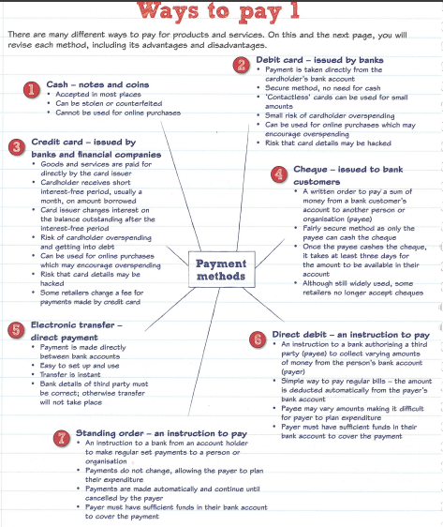• cash

• debit card

• credit card

• cheque

• electronic transfer

• direct debit

• standing order

• pre-paid cards

• contactless cards

• charge cards

• store cards

• mobile banking

• Banker’s Automated Clearing Services (BACS)

• Faster Payments Service (FPS)

• Clearing House Automated Payment System (CHAPS).

