Name:_____________

A-Level Biology: Initial assignment

Welcome to A-level Biology!
The first topics we will study in A-level Biology are Biological molecules and Enzymes which you will be familiar with from school. We would like you to secure your knowledge from GCSE and have a go at some of the early elements of the A-level course by completing this task. Most of this is familiar, but we are also looking for you to use your research skills to source answers to questions and we want you to complete all of this task.
You will be able to find plenty of material online to help with you this assignment but I have aslo added some course material below that you might wish to use to help. Please do not complete this task with the use of AI.

- Toole and Toole A-level Biology text book

- CGP AQA A-level Biology revision guide



As you already know, ENZYMES are PROTEIN MOLECULES. They are BIOLOGICAL CATALYSTS. The reactions in the cells of your body would not happen quickly enough without them!
KEY WORDS:
Product molecules
Substrate molecule
Enzyme
Active site
Complimentary
Protein
Enzyme-substrate complex

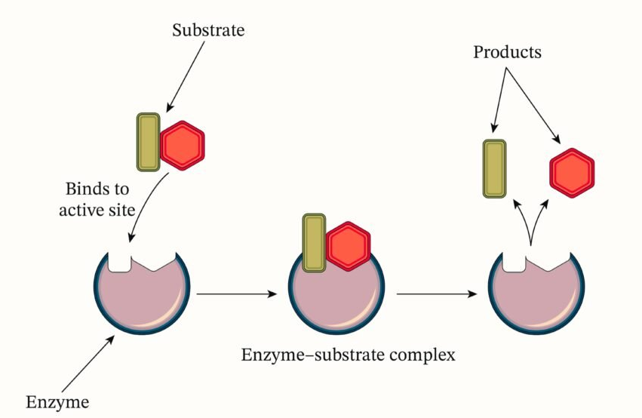
- Label the diagram below. Write a couple of sentences to explain what the diagram shows.

________________________________________________________________________________________________________________________________________________________________________________________________________________________________________________________________________________________________________________________________________
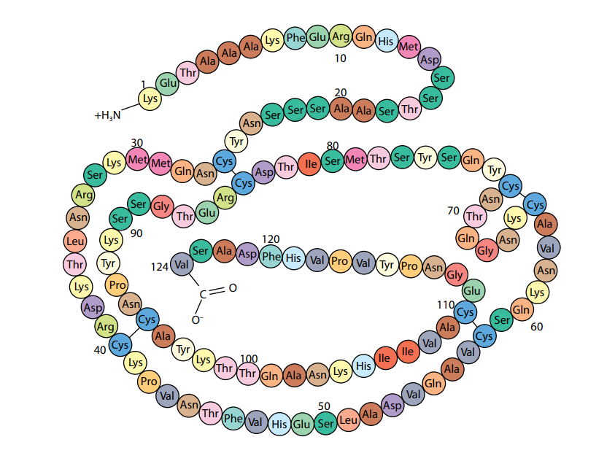
- Enzymes are proteins. What are the monomers that protein molecules are made up of? ___________
The PRIMARY STRUCTURE of a protein refers to the sequence of amino acids joined together to form the protein. This forms a chain called a POLYPEPTIDE. The type and sequence of amino acids in the polypeptide determines WHERE bonds form between different parts of the chain AND the 3D shape that it folds up in to. A protein’s specific 3D shape is known as the TERTIARY structure.
Find out!
What type of bond occurs between individual amino acids in a polypeptide?
What types of chemical bond hold the polypeptide in its tertiary structure?

3.Two enzymes have differently shaped active sites (as they bind to different substrates!). Can you explain what causes these different shapes using the terms AMINO ACIDS, PRIMARY STRUCTURE, TERTIARY STRUCTURE, BONDS (and the information above!!!).
________________________________________________________________________________________________________________________________________________________________________________________________________________________________________________________________________________________________________________________________________
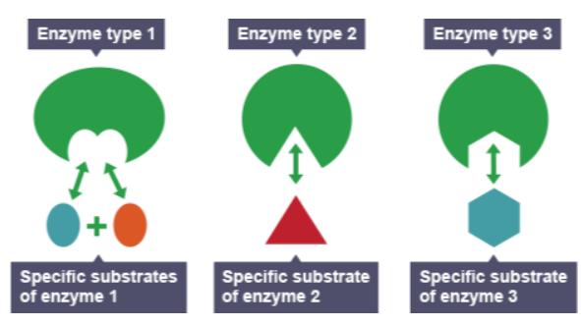
So, enzymes are specific to one type of reaction only because their ACTIVE site has a very specific TERTIARY STRUCTURE meaning it is only COMPLIMENTARY to the SUBSTRATE/SUBSTRATES of a specific reaction.

Factors affecting rate of enzyme-controlled reactions
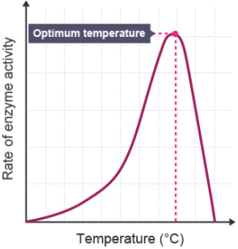
You will already know that TEMPERATURE impacts the rate of an enzyme-controlled reaction.
DESCRIBE the relationship shown in the graph. Simply state what the relationship is between increased temperature and rate of enzyme activity.

EXPLAIN why we see this relationship between increased temperature and rate of reaction by filling in the gaps:
As temperature increases, rate of reaction ____________ due to the enzymes and substrate molecules having more ___________ energy. This means they will __________ more often leading to more successful reactions. This is up to a certain point which is the enzyme’s ____________ temperature. Rate of reaction drops sharply following this due to the enzyme being ___________. This happens due to the hydrogen and ionic ________ holding the enzyme in its specific tertiary structure being broken.
Denaturation
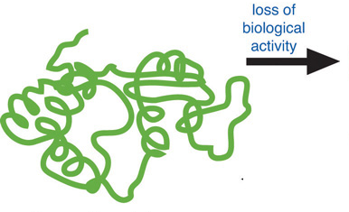
Below shows the very specific shape of an enzyme. As you know now, this is a polypeptide held together by bonds in very specific positions. Draw a picture to suggest what the enzymes might look like once DENATURED.
Active site

Why is the enzyme unable to bind to its substrate (and therefore speed up the rate of the reaction) following denaturation?_________________________________________________________________________________________________________________________________________________________
pH
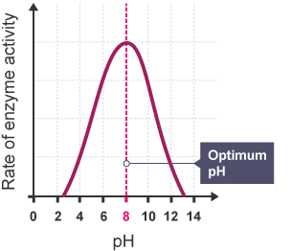
As you will know, different enzymes work best at different optimum pH values. The enzyme represented on the graph has an optimum pH of pH 8. It works within a range of approximately pH2-pH13. Outside their working range they become denatured.
Pepsin is an enzyme located in the stomach. It works between a range of pH1-pH4 and has an optimum pH of 2.5.

Catalase is an enzyme that is found in particularly high concentrations in the liver. It works between a range of pH7-pH11. It has an optimum pH of pH 9.
Add a line to the graph for both pepsin and catalase to show how pH affects their rate of reaction.
Substrate concentration
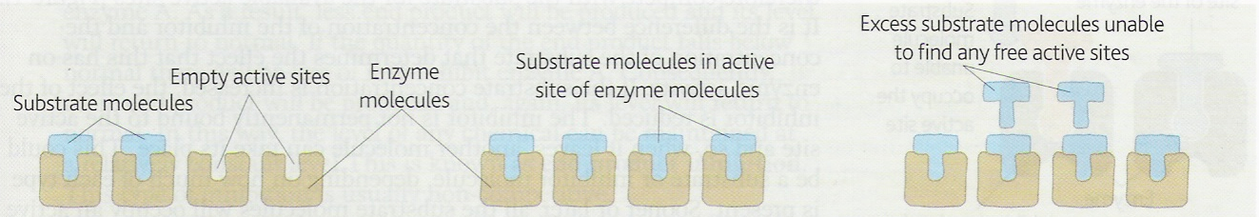
The concentration of substrate used in an enzyme-controlled reaction can impact the rate of the reaction. The graph below shows the results of an experiment that was carried out to demonstrate this. A scientist carried out an enzyme-controlled reaction at 7 different substrate concentrations (0,10,20,30,40,50,60 arbitrary units). They plotted the maximum rate of reaction for each substrate concentration on the graph below.
Can you use the graph and the diagram above to explain the following:
Rate of reaction is at its lowest at point A on the graph:___________________________________________________________________________________________________________________________________________________________________________________________________________
Rate of reaction is higher at point B: ________________________________________________________________________________________________________________________________________________________________________________________________________________
Rate of reaction between C and D does not increase any further:______________________________________________________________________________________________________________________________________________________________________________________________________________________________________________________________

High substrate concentration
Low substrate concentration
Medium substrate concentration
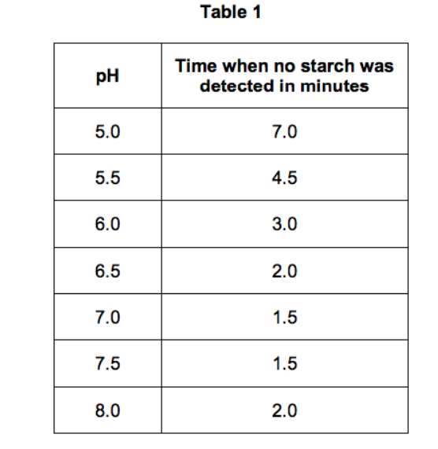
Investigating enzyme activity
A student investigated the effect of pH on the activity of amylase.
This is the method used.
- Mix amylase solution and starch suspension in a boiling tube.
- Put the boiling tube into a water bath at 25 °C.
- Remove a drop of the mixture every 30 seconds and test it for the presence of starch.
- Repeat the investigation at different pH values.
Seven different pH values were used. The results are shown in Table 1.
What is the independent variable in this investigation? ____________
What is the dependent variable in this investigation? _____________
Name a variable that would need to be controlled in this investigation. Explain why it must be controlled.
____________________________________________________________________________________________________________________________________________________________________
How could the scientist determine whether starch is still present in the boiling tube or not?
______________________________________________________________________________
The scientist concluded that the optimum pH for this reaction (the break down of starch) would be 7.25. This is not a valid conclusion. Can you think of two reasons why? ________________________________________________________________________________________________________________________________________________________________________________________________________________________________________________________________________________________________________________________________________
The entire experiment (all pH values) was repeated BUT at 37ºC. How do you expect the results to differ and why?
________________________________________________________________________________________________________________________________________________________________________________________________________________________________________________________________________________________________________________________________________
The scientist carried out the investigation at pH 1. After 30 minutes starch was still present in the sample. Can you suggest why?
________________________________________________________________________________________________________________________________________________________________________________________________________________________________________________________________________________________________________________________________________

EXTRA CHALLENGE!!!
Enzyme Inhibitors
Inhibitors are chemicals that can slow down or prevent an enzyme-controlled reaction from happening. There are two types COMPETITIVE INHIBITORS and NON-COMPETITIVE INHIBITORS.

Xanthine is a chemical found in the human body. It is formed when Guanine (a DNA base you might have heard of!) is broken down. The Xanthine can then be broken down in to a chemical call Uric acid. A disease called Gout is caused when Uric acid builds up in a person’s joints.

What is the name of the enzyme that catalyses the conversion of Xanthine to Uric acid?_______________
Gout can be treated using a drug called Allopurinol. It acts as a COMPETITIVE INHIBITOR.
Xanthine unable to bind to the enzyme

The diagram shows how Allopurinol is used to treat Gout. Can you use the diagram and your knowledge of how enzymes work to explain how you think Allopurinol is able to treat Gout (what do you notice about the shapes/tertiary structures of Xanthine and Allopurinol?)?

Xanthanine Oxidase

Allopurinol

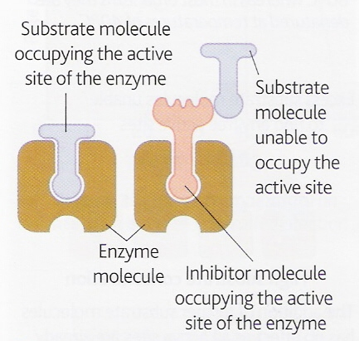
Xanthine

NON-COMPETITIVE INHIBITORS also slow down enzyme-catalysed reactions. They do no bind to the active site. Can you research how they slow down a reaction?
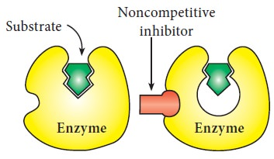

Well done! We look forward to welcoming you to Biology in September!

