

ASFC Free Meals Form 2026/2027
Office use only:
Date received:

EMA number: 3 3 5 0 7 __ __ __ __ __ __ __

The 1996 Education Act requires maintained schools and academy sixth forms to provide free meals to disadvantaged students who are aged over 16. Students aged 19 or over are only eligible to receive a free meal if they either:
- are continuing on a study programme they began aged 16 to 18 (‘19+ continuers’)
- have an EHC plan

From the start of the 2026 to 2027 academic year, all students from households in receipt of Universal Credit will be entitled to receive a free meal. If you had Free School Meals at high school, please provide proof of this – a letter or an email confirming eligibility is required.

Please supply up to date PRINTED documentary proof of Universal Credit or support under part VI of the Immigration and Asylum Act 1999 or proof from high school.

Free meals allowances are loaded onto college ID cards daily. No unspent money rolls over and is on a use it or lose it basis.

£5 daily allowance for college approved trips and visits will be reimbursed. PTO to fill in bank details.

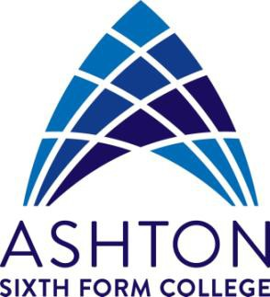
Student’ bank details form for reimbursement purposes

Please enter the students bank details below. (not parents or guardians details)

Student Name:
Account Name:
(Name on Bank Card)
Account Number:
This is 8 digits, not the long card number
Sort Code:  xx-xx-xx
  -
Bank name:
Bursary Services signature:
Ashton Sixth Form Office Staff use only

Bursary Category  Ashton Sixth Form Office Staff use only
  -

