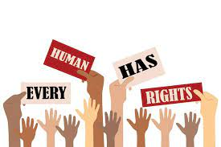
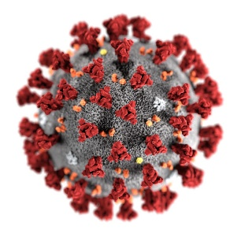
How did Covid-19 impact your Human Rights?

One unit that you will study is Equality, Diversity and Inclusion. As part of that, we look at the Human Rights Act 2000. It was passed by the government in 1998 and became law in 2000.
The Human Rights Act protects every member of our country, however, your Human Rights may have been impacted during Covid-19 pandemic and the lockdown(s) that we have had.
Using the following information to help you, I would like you to research which of your human rights you feel may have been impacted due to Covid-19 and why.
Introduction
Explain what Human Rights are and what Covid-19 is.
Use the following links to help you:
https://www.equalityhumanrights.com/en/human-rights/human-rights-act
https://www.bbc.co.uk/newsround/51204456#:~:text=Coronavirus%20is%20a%20new%20flu,coronavirus%20and%20find%20a%20vaccine.
Main body
Think about how Covid-19 impacted your life. Now look at the Human Rights act that sets out your freedoms. Consider the following questions and use evidence and research to support your thinking:
- Were you allowed to move freely?
- Were you allowed to meet in groups?
- Were you allowed to express your views in protest?
- What other aspects of your human rights do you feel may have been infringed?
- Any that apply to others? For example, do you know anyone who wasn’t allowed to get married, infringing their human rights?
- Do you think the government infringed your Human Rights? If so, how? If not, why?
- Do you think the government were right to infringe your Human Rights? Why/why not?
- Why do you think the government were allowed to do this?
- Were there any instances where you thought the government were hypocritical?

Conclusion
Answer the title: How did Covid-19 impact your Human Rights?
Tell me how YOU think Covid-19 impacted your human rights. Give your opinion, but try to back it up with evidence that you have found with your research. Also, consider the other side of the argument to your thinking. This shows a greater depth of understanding.

