2017/18
Induction Booklet
Induction tasks
2017/18
BTEC Applied Science
This Photo by Unknown Author is licensed under CC BY-SA

Welcome to Applied Science!
Our aim is to ensure that you thoroughly enjoy studying science and we will provide help, support and guidance throughout the course (and a kick up the bum when you need it!). We want to ensure that you reach your full potential and we hope that the enthusiasm of our highly qualified staff will allow you to reach your goal. You will find excellent laboratories that are both well-equipped and pleasant to work in. In addition, there is information about careers and university courses in ST2.1 (the Science & Technology computer room).
Whilst we expect you to work hard, we hope that you find your Science lessons stimulating and enjoyable.
Your background in Science
Before arriving here many of you will have studied Science at school. Some of you will have followed separate subject Science courses and others Double Science courses. For this reason we do not assume that everyone has a full knowledge of GCSE science topics. Rather, we approach each unit by starting with the basics and then building upon this.
When we cover a topic which you have met at GCSE, do not assume that you know it all already - we will be teaching it in more depth and expecting more detail and understanding than before. Don’t worry if you struggle at first - this is quite normal. As long as you are prepared to work hard and come and ask for help, you will get over this initial period.
BTEC Science Our department comprises:
Sara Petts- spe@asfc.ac.uk (Head of Department)
Chris Ellison-cell@asfc.ac.uk
Natalie Lorenzen-nlor@asfc.ac.uk
Peter Stiles-psti@asfc.ac.uk
Val Roach-vpr@asfc.ac.uk
Alison Isaac (technician)
Troy Weston (technician)
During the course you may be taught by more than one of us. Remember that if you have a problem and require help you may ask any one of the tutors. When not teaching we can be found in the Science office.
Course at a glance
At Ashton we follow the BTEC Level 3 Applied Science specification. There are a number of courses at the college which may seem complicated at first. Here is a breakdown of what we offer:
BTEC Certificate in Forensic Science or Medical Science
This is the qualification you will achieve at the end of year 1. When followed for two years these are each equivalent to 1 A level. Successful completion of the second year will lead to the BTEC Subsidiary Diploma qualification.
BTEC 90 Credit Diploma in Forensic Science
This is the qualification you will achieve at the end of year 1. The course when followed for two years is equivalent to 3 A levels. Successful completion of the second year will lead to the BTEC National Extended Diploma (NED) qualification.
You will not sit any exams and the units you study will depend on which course you do. There are some compulsory units and these will be studied by every student in the department. They are outlined below:
Unit 1: Fundamentals of Science
Unit 2: Working in the science industry
Unit 4: Scientific practical techniques

Movie Recommendations
Yes that’s right. There are some great films linked to science and perfect for a rainy day! Here are our top 5 recommendations.
Inherit the wind (1960): Based on the real life trial of a teacher accused of teaching Darwinian evolution.
Lorenzo’s oil (1992): The parents of a child with an autoimmune disorder challenge Doctors to find a new cure. Based on a true story
Gorillas in the mist(1988): An absolute classic must watch! Based on the life work of Diane Fossey and her bid to protect
mountain Gorillas from poachers and habitat destruction.
Something the lord made (2004): A black man in the 1930’s is originally hired as a janitor but proves himself adept at assisting the “Blue Baby Doctor” with his medical research. This film stars the late Alan Rickman and also tackles themes of predjudice.
The Andromeda strain (1972): Written by Michael Crichton (of Jurassic Park fame) people start to become very ill when infected by alien microbes.

If you have 30 minutes to spare, why don’t you watch a presentation from a leading scientist? Visit www.ted.com to find your favourite, here are a couple to get you started.
How to get help
No one expects you to know the answers to all the questions you might be asked just by coming to lessons. You must be prepared to seek out assistance if you are to make progress at this level.
You can obtain help in a number of ways:
- Speak to your teacher at the end of the lesson. If the query is straightforward, you can be given some help. If it will take more time to explain than is available before the next lesson, your teacher will arrange a mutually convenient time for your problem to be discussed.
- Come and find any of the science staff when you are free. As long as there is someone available to speak to you, your problem can be discussed immediately.
- Come to one of the Subject Support Sessions that we run at various times throughout the year. These are informal sessions where problems arising from class work or homework assignments can be discussed with one of the science staff. Check the notices around the labs for details of times and places of topic specific sessions.

Science department
What you can expect from us:
- The setting of worthwhile tasks to improve scientific skills and knowledge through a variety of approaches
- Guidance and monitoring to improve your Scientific skills
- The regular setting, marking and prompt return of work
- Regular feedback to identify problems, find solutions and give direction for the future
- To try to make lessons enjoyable, interesting and stimulating
- Full coverage of the syllabus and preparation for University
- Confirmation in the first few weeks that the course is the right one for you and your skills. If this is not the case we will recommend transfer to something more suitable for you
- Daily support from either a teacher or A2 students

What we expect from you:
- To come prepared to work hard in lessons and participate fully. This includes having completed your lesson preparation work as well as making sure you have a pen, pencil, ruler and calculator
- Safe working practice throughout
- Completion of all work set to realistic deadlines
- Work is completed at the best possible standard you can attain
- If you are absent through illness / visit to a university etc., you take responsibility to complete any work missed
- You get help from a teacher or classmate if you have not understood work done in class, need homework help, or need to catch up after absence
- Do more than just the set work! Just turning up to class and doing homework is the absolute bare minimum. For a high grade you need to have excellent attendance, great punctuality, high grades in coursework and tests and have done extra reading, practising, reviewing and researching
- No inappropriate or unauthorised use of mobile phones in lessons
- Self motivation! This is your BTEC course!
- Complete a minimum of 4 hours private study per week. More if you’re aiming for a high grade!

Don’t forget:
- If you are unable to attend a class you must call the college reception to inform us. Tel. 0161 330 2330
- If you need to speak to a member of the team, call ext. 302
- Alternatively you can contact us by email.

Safety code: Science department
It is very important to keep the laboratory a safe place to work, therefore you must always abide by the following:
Before the lesson starts you must:
- Never go into a laboratory without permission
- Always walk in the laboratory and never run or push anyone
- Always remove/secure your coat, hat, watch, jewellery etc. as appropriate
- Always fasten loose clothing etc.
- Always tie back long hair and scarves
- Place your bag under the bench or in the storage cubes
- Never eat or drink in the lab

During the lesson you must:
- Always follow the instructions as provided by the teacher
- Work sensibly and quietly to minimise hazards and to ensure that you can hear any instructions
- Always wear safety goggles / glasses when heating anything, working with chemicals or when told to do so
- Always wear a lab coat when completing practical activities
- Always put your stool under the bench if you leave your seat
- Always report an accident or breakage immediately. If you spill anything on yourself, immediately wash with water and call for your teacher’s help
- Never put anything in your mouth
- Never interfere with apparatus
- Never put glass or solids down the sink
- Never sit on the benches unless instructed to do so
- Never remove safety screens or notices
- Always wash and dry your hands thoroughly as appropriate

At the end of the lesson:
- Clean any equipment used and return it as instructed by your teacher
- Wipe the benches, tables and sink areas if they are wet
- Wash and dry your hands
- Leave the laboratory clean and tidy
- Return your lab coat

Referencing and Quotations
Referencing systems for electronic sources are becoming standardised. The in text reference should follow the same format as for printed resources. However the bibliographic information on your references page will be different and generally requires you to include the type of resource plus when it was accessed as well as the URL for online sources.

For example:
British Sports-Disability Sports online reference:
http//www.britishsports.com/disabilitysports.htm (downloaded 11th July 2017)

General Quotations
When using a quotation you will reproduce the actual words a writer uses in your work. You should therefore take care to copy it accurately. If you copy the actual words a writer uses you should put thewords in quotation marks (“”) and give a reference.
In this example:
Jack Frost wrote “summer is not coming in” (this is the quotation)
(Frost A 2001 p9) would appear in the text (this is the reference)

Plagiarism
Plagiarism is copying and passing off work as the learners own. This can be a whole piece of work or a part, including artwork, images, words, computer generated work (including the internet) Thoughts, inventions etc. This is taken very seriously and work handed in that has a form of plagiarism will not be accepted.
To ensure you do not plagiarise, write using your own words. If you do use the work of others e.g. books, internet etc you must reference it using the protocol above.

Initial Assessment
You must print the relevant sections and take them to your first lesson. Complete all tasks if you are starting on the 90 Credit Diploma course. Complete tasks 1 and 2 only if you are starting the BTEC Certificate. Complete each task as well as you can and sign to acknowledge your understanding of the lab rules and those regarding plagiarism.
Name………………………………………………………………………………………………………………………………………………
I have read and understand the health and safety rules and agree to follow them at all times in the laboratory
signed…………………………………………………………………………………………………………………………………………….
Date……………………………..
I have read and understand the information on plagiarism and agree to acknowledge all others work and to only submit work that is my own
signed………………………………………………………………………………………………………………………………………………
Date…………………………….

BTEC Induction Assignment:
Hand this in as a separate report and include any references used at the end.

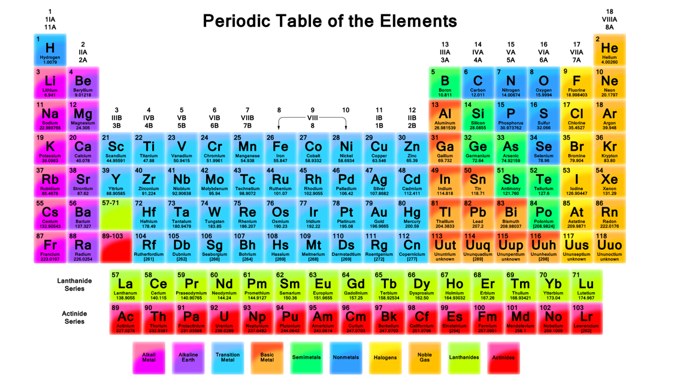
Physics
Part 5
The purpose of this exercise is to see how you analyse and present data in a scientific way.
Investigating how the Length of a Pendulum effects the Swing Time
The length of a pendulum was altered and the time taken for each swing was measured. The time of each swing was measured 3 times so that an average value could be found. The results were:
(length = 10 cm, time 1 = 2.7 sec, time 2 = 3.1 sec, time 3 = 2.5 sec)
(length = 20 cm, time 1 = 6.2 sec, time 2 = 5.7 sec, time 3 = 6.5 sec)
(length= 30 cm, time 1 = 9.7 sec, time 2 = 8.6 sec, time 3 = 9.2 sec)
(length= 40 cm, time 1 = 12.6 sec, time 2 = 11.9 sec, time 3 = 12.2 sec)
(length= 50 cm, time 1 = 15.8 sec, time 2 = 14.4 sec, time 3 = 15.3 sec)
(length= 60 cm, time1 = 18.2 sec, time 2 = 17.6 sec, time 3= 18.4 sec)
Task 1
Present the results above results in a table using correct headings and including correct and appropriate units. You should have a column for time 1, time 2 and time 3 and a column for the average time.

Task 2
Using the data presented in your table, produce a graph of your results. Choose an appropriate style of graph and correctly label the axes.
Task 3
Draw the most appropriate line of best fit for your points. Find the gradient of this line and express the value of the gradient to 2 decimal places (2 d.p.).

Task 4
The period for a pendulum may be roughly given by the equation T = 6.28 x (length of string in meters/0.2). Work out the expected period for a pendulum of length of string of 40 cm. Calculate the difference between the calculated value and the value you found for a pendulum of length of string 40 cm in the data. Express the difference to 2 significant figures (2 s.f.).
Task 5
Produce a graph from the data in the table below. Draw a line of best fit for the points and identify any anomalous results.
Mass of pendulum (kg) | Period (seconds)
2 | 26
3 | 21
5 | 17
7 | 11
9 | 10
13 | 8
21 | 3

